S228/105C
S282/105C



DUBLIN INSTITUTE OF TECHNOLOGY
_____________

BSc. (Honours) Degree in Computer Science
BSc. (Honours) Degree in Computer Science (International)

Year 1
______________

Assignment 2015
______________

Operating Systems 1 [CMPU1022]

Damian Gordon

Due Date: 15th April 2015.

Answer All Questions.

Questions 1 and 3 are Individual Activities.
Question 2 is a Group Activity.

put all your answers in the accompanying Word document template.

1. | (a) | Write a DOS Batch script to automatically recursively backup files from a specified directory (and all its sub-directories), to a newly create directory called BackupFolder (with the same sub-directories). Finally list all the files recursively in the new BackupFolder.  Provide screengrabs of the script file, a directory listing before you run the script, a directory listing after you run the script, and at least 150 words explaining how you figured out how to make this work, and what each command does.  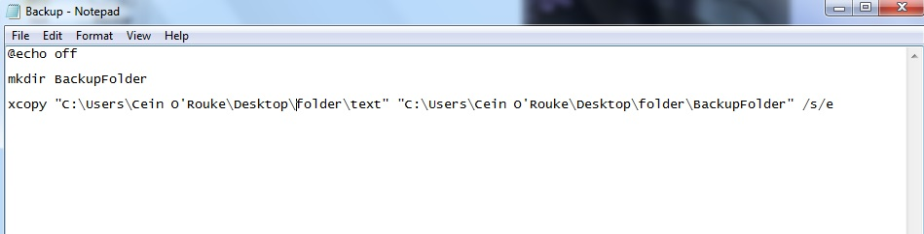
 |  | 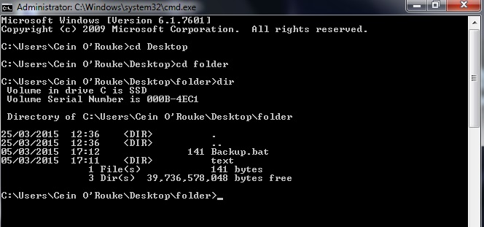  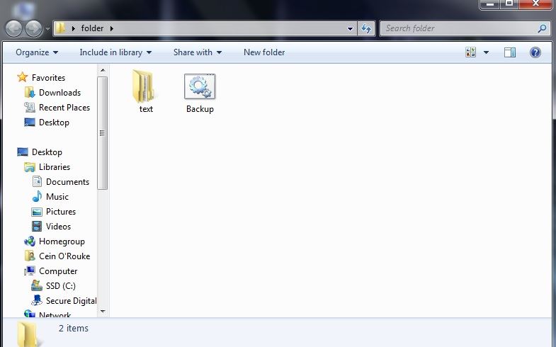  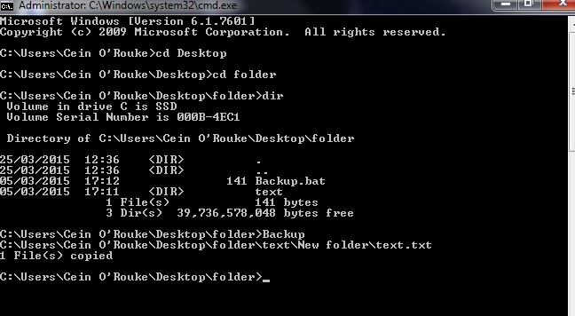  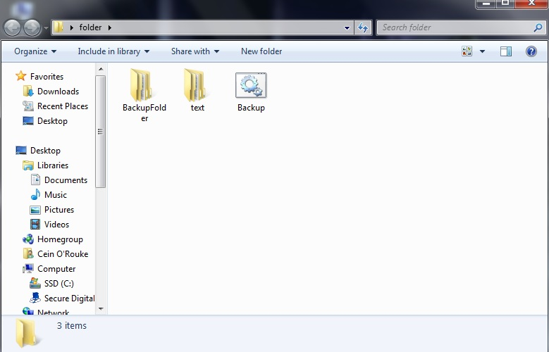  I learned how to do this by looking around on the internet for a while and then I came across the xcopy command. I then looked on youtube on tutorials showing me how to get this working and failed a few times and then learned that I had to have the /s/e at the end of what I wanted to copy to make it work. What I am doing with the commands is making a backupfolder and copying the files the folder I made and the folder itself into the backup folder. | (15 Marks)

1. | (b) | Write a Bash/Linux script to automatically recursively backup files from a specified directory (and all its sub-directories), to a newly create directory called BackupFolder (with the same sub-directories). Finally list all the files recursively in the new BackupFolder, and what each command does.  Provide screengrabs of the script file, a directory listing before you run the script, a directory listing after you run the script, and at least 150 words explaining how you figured out how to make this work.  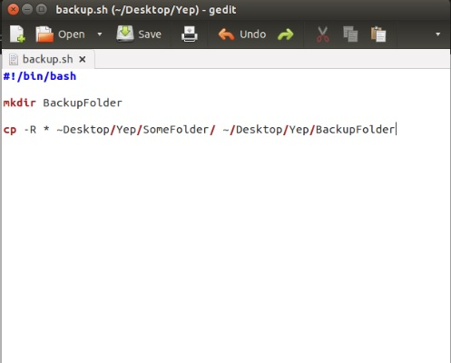  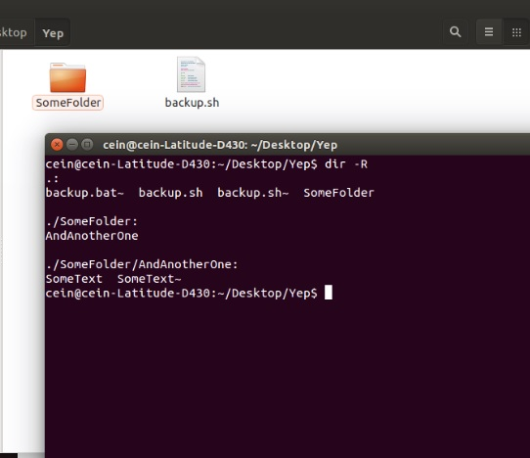  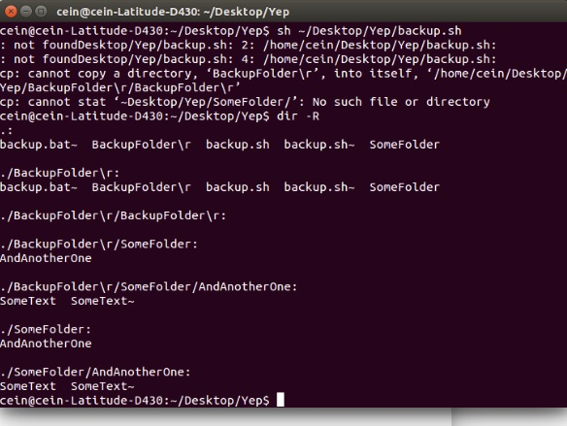  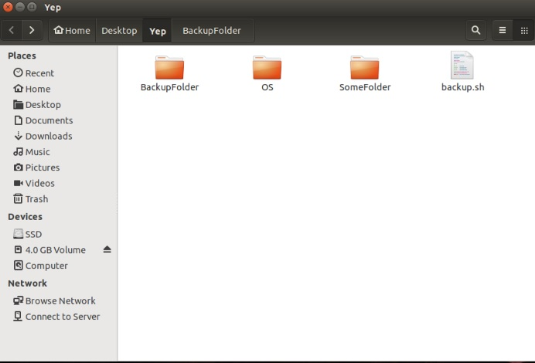  Again I used the internet for the commands to use this and then also with the lab work that we were given was also very helpful. After I used youtube again for tutorial on how to execute what I wanted to do. It took me a while to get the right command for it to work but then I used the sh~ command and it worked. What the commands did again was make a backup folder and copied the folder I made and the contents that were inside the folder. (the OS folder is just the screenshots I took if it looks confusing).
 |  |  | (15 Marks)

1. | (c) | The Little Man model uses a single-digit op-code and a 2-digit memory addressing and has the following instructions defined where the address portion is shown as xx

OpCode | Instruction | Description
1xx | ADD | Add the value of a given memory location to calculator
2xx | SUBTRACT | Subtract the value of a given memory location to calculator
3xx | STORE | Copy the value from the calculator into a given memory location
5xx | LOAD | Copy the value from a given memory location into the calculator
6xx | BRANCH | Unconditional branch. Set the Program Counter to value xx
7xx | BRANCH IF ZERO | Conditional branch. If the accumulator is zero, branch to xx
8xx | BRANCH IF POSITIVE | Conditional branch. If the accumulator is positive, branch to xx
901 | INPUT | Get the value from the IN-TRAY and put it into the calculator
902 | OUTPUT | Put the value in the calculator into the OUT-TRAY
000 | HALT | Take a break

Write a program using these codes to take two numbers which are contained in the IN-TRAY and display the sum (+) of those numbers in the OUT-TRAY. Comment every instruction

901 | Read in first number
308 | Store first number in slot 8
901 | Read in second number
309 | Store second number in slot 9
508 | Load the first number
109 | Add to first number to second number
902 | Put the answer in out-tray
000 | Stop

(20 Marks)

2. | (a) | In the groups specified below you are required to create a presentation.  The presentation is concerning Operating Systems, and needs to be at least 20 slides long, including the following:  - A Cover slide with a title, all the group members, and a suitable image for the topic.  - A Table of Contents slide.  - At least one slide with a biography of someone who helped to create the Operating System or is strongly associated with it. A maximum of six (6) biography slides are permitted.  - A Diagram slide showing your understanding of the architecture of the operating system.  - A Desktop slide where you show an image of the desktop of the operating system.  - A Conclusions slide.

The slides need to be in the following format:
http://www.damiantgordon.com/Courses/OperatingSystems1/OperatingSystems1-Week5-Scheduling.pptx

and the biography slide needs to be in the same format as the one on slide 72 in the above presentation.

The suggested Operating Systems per group are as follows:

1 | AmigaOS | 13 | QNX
2 | Android | 14 | ReactOS
3 | BeOS | 15 | RISC OS
4 | BSD | 16 | Solaris
5 | GNU Hurd | 17 | TPF
6 | Haiku | 18 | Unix
7 | iOS | 19 | VM/CMS
8 | Visi On | 20 | Windows
9 | Mac OS | 21 | z/OS
10 | MorphOS | 22 | Linux
11 | OpenVMS | 23 | DOS
12 | OS/2

But if you don’t want to pick the suggested Operating Systems, you can pick any other real-world Operating System not mentioned in the above list, or a fictional Operating System, e.g.

- The J.A.R.V.I.S. Operating System that controls Iron Man’s suit
- The Operating System from any the U.S.S. Enterprises from Star Trek
- R2D2’s Operating System.

But if you aren’t taking the suggested Operating System, your group needs to email me, and get my approval before you commence.

Now here’s what I want from everyone, submit to me:

- The PowerPoint presentation as specified above

- A two-page Word document documenting your journey, including a list of the group members and your chosen groupname; the roles and responsibilities of group members; how often you met; how did you make decisions? (Democratically/group consensus, team leader has final say??); had you agreed timescales; What resources you used (at least 4 websites)?; Finally a comment of what work each other person in your group did.

- As a group you will be required to present your PowerPoint in class, after Easter.

(35 Marks)

3. | (a) | Copy your solutions for Labs 1 to 4 into the document as well. If you haven’t completed any of them fully, please feel free to correct that before you submit.
 |  |  | (15 Marks)

Acquah, Kewbina, Charles | 1 |  | Byrne, Graham. | 12
Djoussa, Kevin, J. | 1 |  | Harvey, Caoimhe, E. | 12
Kearney, Edel. | 1 |  | Mc Donnell, Bernard, J. | 12
Murray, Amber. | 1 |  | Ragab, Yahia. | 12
Sharma, Vardaan. | 1 |  | Twomey, Mark. | 12
Almulhim, Tariq. | 2 |  | Byrne, Robert. | 13
Donnelly, Joe, J. | 2 |  | Hunt, David. | 13
Kelly, Cormac. | 2 |  | Mc Keon, Shane. | 13
Nevin, Keith, P. | 2 |  | Redmond, Paul. | 13
Singh, Amandeep. | 2 |  | Walsh, Derry. | 13
Ballinger Mcfarlane, Henry. | 3 |  | Cervi, Laurence. | 14
Doyle, Chloe. | 3 |  | Huseynov, Ali. | 14
Keogh, Mark. | 3 |  | Mc Laughlin, Pearse. | 14
Newsome, Aine, B. | 3 |  | Renaghan, Aaron. | 14
Smyth, Eoin. | 3 |  | Wan, Lok-Woon. | 14
Bari, Haashim, A. | 4 |  | Chan, Ka, Y. | 15
Duignan, Connor. | 4 |  | Hynes, James, E. | 15
Kilroy, Karen. | 4 |  | Mc Loughlin, Keith. | 15
Nyondo, Bryan. | 4 |  | Rogers, Cliona, L. | 15
Sweeney, Alexander, D. | 4 |  | White, Colin. | 15
Boyce, Jack. | 5 |  | Clooney, Greg. | 16
Essien-Thompson, Elihu. | 5 |  | Igoe, Elliot. | 16
Kupsyte, Dovile. | 5 |  | Miley, Shane, R. | 16
O Donnell, Niall. | 5 |  | Sabio, Pamela, L. | 16
Synica, Aleksander. | 5 |  | Wijntjes, Robert, A. | 16
Brady, Alex. | 6 |  | Cunningham, Felix. | 17
Fitzgerald, Katie. | 6 |  | Ilori, Adewole. | 17
Lalor, Liam. | 6 |  | Mukhambetali, Pussyrman. | 17
O Neill, Simon. | 6 |  | Salomon, Jelo. | 17
Szlachetka, Eryk. | 6 |  | Witte, Alexander. | 17
Breen, Colm. | 7 |  | Dagg, Desmond. | 18
Fogarty, Kieran, C. | 7 |  | Kavanagh, Carl. | 18
Lat, Francis, J. | 7 |  | Mullins, Alannah. | 18
O Nuallain, Ciaran. | 7 |  | Sanehi, Behzad. | 18
Tang, Eamon, W. | 7 |  | Young, Jake. | 18

Brennan, Eanna. | 8 |  | De Souza, Jonatans, A. | 19
Forde, Jordan. | 8 |  | Kavanagh, Zephan, Y. | 19
Leech, Andrew. | 8 |  | Murphy, Conor. | 19
O Rourke, Cein, F. | 8 |  | Shah, Abdullah. | 19
Tilley, Daniel. | 8 |  | Zat, Vlad, M. | 19
Brownlow, Josh. | 9 |  | Devilly, Conor. | 20
Furlong, Kevin. | 9 |  | Kazydub, Maria. | 20
Long, David. | 9 |  | Murphy, Ross. | 20
Othman, Fahid. | 9 |  | Shanahan, Benjamin, R. | 20
Timmons, Seamus, E. | 9 |  | Zimmerman, Oliver. | 20
Bruveris, Martin. | 10 |  | Davydenko, Vladimir. | 21
Grimes, Daire. | 10 |  | Curran, Eoin. | 21
Mc Cabe, Cillian, J. | 10 |  | Mc Girr, Stephen. | 21
Owens, Andrew. | 10 |  | Purcell, Sean. | 21
Tipones, Mary Louisse. | 10 |  | Nugent, Peter. | 22
Butler, Dylan. | 11 |  | Dunne, Gareth. | 22
Hanlon, Sean. | 11 |  | Molcalut, Razvan, I. | 22
Mc Carthy, Padraig. | 11 |  | Murphy, Nathan. | 22
Petcov, Oleg. | 11 |  | Ridha, Mohammed, A. | 23
Turner, Karl. | 11 |  | O Connor, Thomas. | 23
 |  |  | O Donoghue, Gary. | 23
 |  |  | Okolie, Amoge. | 23

Plagiarism:
You will get zero if you plagiarise. I will also make sure you are brought before a plagiarism panel, and will push for you to get as severe a punishment as possible.

Submission Date and Details:
You are required to submit by the due date stated above. You will submit your assignment using the template file on this webpage. Your submission will be in the following two ways (1) by email with an email heading OPERATING SYSTEMS 1 ASSIGNMENT #1, and (2) print out and hand up to my in class your completed submission.

